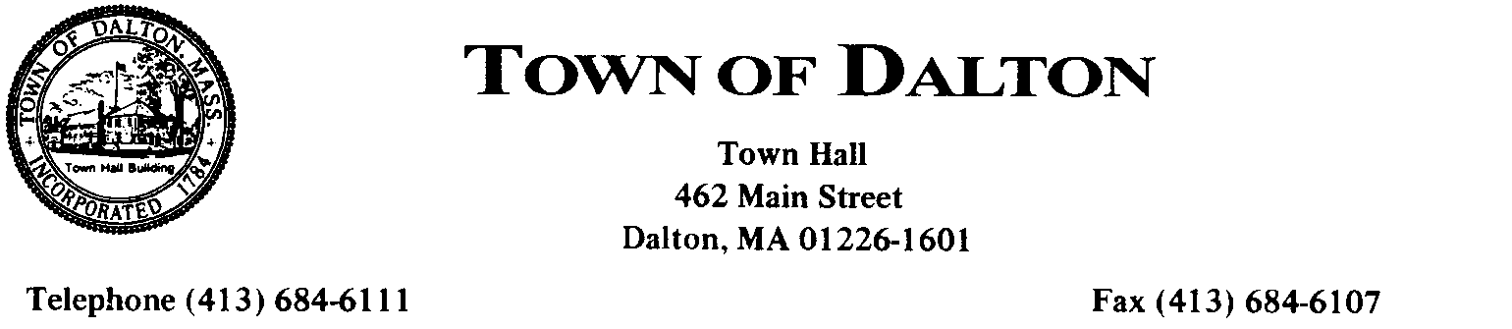
APPLICATION FOR ONE-DAY ALCOHOLIC BEVERAGE LICENSE
AND OR ENTERTAINMENT LICENSE

Date _____________
To: THE DALTON LICENSING BOARD:
I hereby make application for a special one-day alcoholic beverage license for the purpose of selling and/or dispensing Beer/Wine beverages as permitted by law at a __________________________.
(event)
___________________, to be held by ___________________________________________
(name of individual/corp.)
______________________________on__________________________________________
(date of event)
between the hours of _____________________________at the following premises ______________________
____________________________________________________________________________
(location address)

Type of alcohol to be served/dispensed: Beer & Wine _____$40.00
All Alcohol _____$60.00

I request a permit for ENTERTAINMENT. _______ $40.00
Form of Entertainment requested:____________________________

Applicant is required to obtain the following signatures:

________________________ __________________________
Police Chief date Fire Chief date

________________________ __________________________
Building Commissioner date Board of Health Agent date
To the best of our knowledge and belief, We, the undersigned, concur that the event outlined above meets all local,
federal, and state laws regulations, by-law, rules, and codes, pertaining to our areas of responsibility.

I certify that I will be responsible for the proper observance of the laws governing the dispensing of such alcoholic beverages.

_______________________________
(Signature)
_________________________________
(Name)
_______________________________
(Address)
_______________________________
(Telephone)
Filed ____________________
Fee $__________paid _______
Hearing date: ______________

